The CSS (layout.css), contains the main elements for 5 webpage sections.

1. Home Page (To do)
2. Food (Done)
3. Famous People (To do)
4. Monuments (To do)
5. Mythology (Done)

***BEFORE YOU START***

**Make sure to grab a link whenever you are getting an image as it will go into a credits page at the end.**

***GENERAL***

**Backgrounds**

Use a unique background image for each page in your section of the website. Relate it to the content.

E.g. if I’m doing Chinese Food then the I’d use a Chinese restaurant as the background.

**Videos**

To insert a video into your page, first insert this html code as a section heading:

<h2><span> Videos </span></h2>

After that all you need to do is find the video you want to insert, click on share, click on embed, and paste the text after the heading. I think a lot of the html is redundant but I don’t think it matters.

Have 2 or 3 of these at the bottom of each page. I don’t think we’ll need any for the index pages.

**Examples**

**Here’s an example of 2 videos.**

<h2><span> Videos </span></h2>

<iframe width="560" height="315" src="https://www.youtube.com/embed/wsTv9y931o8?si=FApj8apzQFMP_7oM" title="YouTube video player" frameborder="0" allow="accelerometer; autoplay; clipboard-write; encrypted-media; gyroscope; picture-in-picture; web-share" referrerpolicy="strict-origin-when-cross-origin" allowfullscreen></iframe>

<iframe width="560" height="315" src="https://www.youtube.com/embed/JYfiaSKeYhE?si=lpsvXJk1VifjLo-H" title="YouTube video player" frameborder="0" allow="accelerometer; autoplay; clipboard-write; encrypted-media; gyroscope; picture-in-picture; web-share" referrerpolicy="strict-origin-when-cross-origin" allowfullscreen></iframe>

(The screenshot is cut off)

***HOME PAGE***

**Language**

To insert a translation of your language, insert this html code:

It’s recommended to basically just use this as an opener for the page. Used to translate hello in your native language.

***Food***

**Food**

To insert a piece of food, use this html code (You can copy it, it’s text not an image):

<section class="cuisine" dir="rtl / ltr" style="background-color: Your Background Color;">

    <h1 style="color: Text Color"><span> Name of Food </span></h1>

    <img src="your.jpg" alt="Name of Food">

    <p style="color: Text Color;"><span> Explanation of Food </span></p>

</section>

The background color should probably be similar to the image you’ve provided so the transition isn’t jarring. (E.g. Use brown if it’s bread). You can use a color dropper if needed.

The text color should either be black or white. Whichever is easier to read on the background color you’ve chosen. Use black if it’s light and white if it’s dark. Rtl / ltr is used for whether you want the image to be displayed on the right or the left. I’d recommend just varying it between each one you add. You can see the examples below to see how it works.

Add as much of this code as needed. (E.g. twice if you want to show 2 foods.)

**Examples**

<section class="cuisine" dir="ltr" style="background-color: #d57b49;">

    <h1 style="color: black">Pizza</h1>

    <img src="pizza.jpg" alt="Pizza">

    <p style="color: black;"> Pizza is without any doubt the most

                                popular and appreciated food in the world.

                                Simple yet tasty, versatile and

                                easy to enjoy everywhere.

                                Perfect for sharing with family

                                and friends pizza can easily

                                satisfy and meet everyone's taste.</p>

<section class="cuisine" dir="rtl" style="background-color: #d57b49;">

    <h1 style="color: black">Pizza</h1>

    <img src="pizza.jpg" alt="Pizza">

    <p style="color: black;"> Pizza is without any doubt the most

                                popular and appreciated food in the world.

                                Simple yet tasty, versatile and

                                easy to enjoy everywhere.

                                Perfect for sharing with family

                                and friends pizza can easily

                                satisfy and meet everyone's taste.</p>

Note that the html doesn’t contain <span> as I made these before I added it.

**Famous People**

To insert a famous people section, insert this html code:

After inserting the section, you can put as many famous people as you want by adding the following code between as many times as needed:

**Monuments**

To insert a monument section

After inserting the section, you can put as many monuments as you want by adding the following code between as many times as needed:

**Mythology**

To insert a myth, use this html code:

<section class="mythology" dir="ltr / rtl">

    <h1><span> Name of Myth </span></h1>

    <img src="your.jpg" alt="Name of Myth">

    <p><span> Explanation of Myth </span></p>

</section>

The rtl / ltr is the same is the food section.

Add as much of this code as needed. (E.g. twice if you want to show 2 myths.)

**Examples**

<section class="mythology" dir="ltr">

    <h1>ICARUS</h1>

    <img src="/WEB-DESIGN-GP/IMAGES/Icarus.jpg" alt="Icarus">

    <p> Icarus was the son of Daedalus, a craftsman who made

        wings of wax and feathers to escape from Crete. He

        flew too close to the sun and fell into the sea,

        becoming a symbol of hubris and overreaching. </p>

</section>

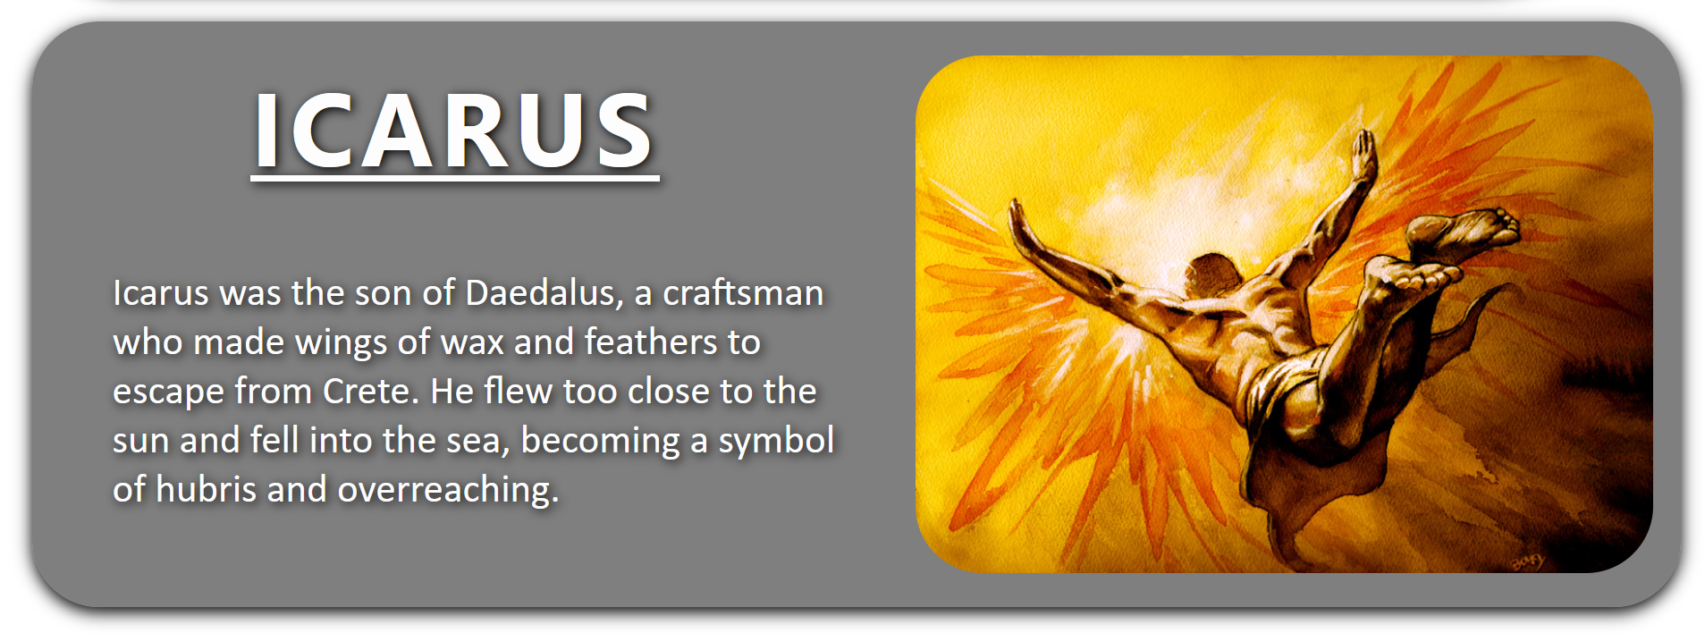

<section class="mythology" dir="rtl">

    <h1>ICARUS</h1>

    <img src="/WEB-DESIGN-GP/IMAGES/Icarus.jpg" alt="Icarus">

    <p> Icarus was the son of Daedalus, a craftsman who made

        wings of wax and feathers to escape from Crete. He

        flew too close to the sun and fell into the sea,

        becoming a symbol of hubris and overreaching. </p>

</section>

**Videos**

You can embed a video in your page using this piece of code:

I’d probably put 2 or 3 at the end of your page. Try to diversify the videos. Perhaps one on nature, the capital, culture etc.

<section class="cuisine" style="background-color: #d57b49;">

<h1 style="color: black">Pizza</h1>

<img src="pizza.jpg" alt="Pizza">

<p style="color: black;"> Pizza is without any doubt the most popular and appreciated food in the world.

Simple yet tasty, versatile and

easy to enjoy everywhere.

Perfect for sharing with family

and friends pizza can easily

satisfy and meet everyone’s taste.</p>

</section>

